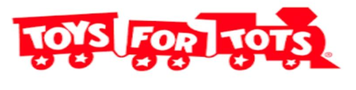
Williamsport Bassmaster 1st Annual Toys for Tots Benefit

We would like to sincerely thank all the sponsors and donors who made this event a huge success. We were able to donate over $6000 in toys to help local children have a merry Christmas.
The following sponsors helped to make this possible:
Rennie Rodarmel (Berger Septic) Blaise Alexander Dealerships
Mike Kutney Insurance Agency Liberty Games
Glen & Nicky Gough (Antlers on the Water & Trail Inn) Keystone Scales
Kriger Fence Lundy Construction
Bimbo Bakery and Grocery Haulers Tates (Beverage Barn)
Jeffrey Hills Fairfield Ford Dealerships

We would also like to thank all the following donors:
Early Bird Car Wash K&W Tire Jaysburg Subs
Winner Hardware Hellers Market Donna & Jim Gamble
K&M Tire Eric Showers Matt Page Trucking
Frankie Subs Joe’s Pizza Valley Inn
Mazzullo’s Auto Spa Sub Way Hall’s Marine
Wegmans Steve McConnell South Side Sports
Park Pizza Danny Poust Dave’s Repair
Phillip & Tiffany Holmes Rusty Splain & Jess Strailey Penn Power

Also, a special thank you to all the fisherman who participated and fished in the rain and the club members and their wives who helped to make this all possible.

